Appreciative Inquiry Practicum
January 2012

- Please include your name, title, email address, phone number and agency that you work for.

Name: Marguerite Sacco Turner
I am a self-employed consultant and facilitator, specialising in Organisational Development (OD). My work involves performing an analysis of the organisation, or a selected business unit and developing the ‘people’ process to facilitate organisational progress and effectiveness. I am a Certified Organisational Analyst, and in that capacity I use Transactional Analysis as my medium for organisational diagnosis and implementation of relevant change processes. I now use Appreciative Inquiry as a further mode for organisational change processes.

- Please include the AIFT Dates and location that you received your training.

I received my AIFT in Cape Town on 18 to 21 August 2009.

- Brief description of the organisation, group, or community you worked with.

My Appreciative Inquiry practicum was done with the country’s official weather intelligence provider. They are a member of the World Meteorological Organization (WMO) and have been in operation for over a hundred and fifty years gathering weather information for the country. Operating as an agency under the Ministry of Environmental Affairs and Tourism and governed by a board of directors, they became a public entity in 2001. They provide two distinct services, namely “public good” services that are funded by government, and “paid-for” commercial services. Their services include Aeronautical meteorological support; Maritime Services; General Forecasting &Technical Services; Observations research; Prediction research; Climate Environment and Research Monitoring; Long-term Atmospheric Monitoring; Air Quality Modelling; Climate Change and Variability applications; and Meteorological Training.
The organisation’s vision is to be the foremost provider of relevant services in respect of weather, climate and related products, which contribute to sustainable development in the country, and in the African Continent.

Their mission is as follows:

“We, in line with our quality policy statement, provide useful and innovative weather, climate and related products and services for (the country) and the African Continent, through:
Enhancing observational data and communication networks;
Effectively developing and managing talent;
Enhancing collaborative partnerships and effectively disseminating weather products to users;
Utilising cutting edge technology to convert data into meaningful products and services for risk mitigation;
Advancing the science of meteorology, research and relevant applications;
Enhancing fiscal discipline and optimal resource mobilisation to ensure sustainability;
in order to inform decision making and contribute to the safeguarding of life and property.”

And the organisational Values are as follows:
Professionalism – Pride in service, passion, discipline, customer orientated.
Integrity and honesty - Trust, ethics, do what you say you will do.
Respect - Appreciating diversity, listening and hearing others, welcoming alternative points of view.
Recognition of excellence – Do it right the first time, cutting edge, best in class, outside the box, reward those who do, differentiate performance, meritocracy.
Teamwork and partnership - Proactive, interventionist, involved, integration, work together towards a common vision.
Accountability - Transparency, value for money, respect the right to recourse.

- List the names and/or category of stakeholders you included in the Core Group, the cross-section of people that helped you identify the topic and modify the Interview Guide.

When I was approached to do this work, the brief given to me was to bring an intervention that would assist the Executive Management Team, (EMT) in positively adjusting to a particular change that the organisation went through earlier in the year: Where previously the organisation only did work for the “public good”, which was funded by government and delivered at no charge to the client, the organisation was now being asked to introduce a commercial element to its work, so as to fund itself and become less reliant on government sponsorship. While some of the executive team embraced this change, others were having difficulty with it, which was affecting morale and motivation.

As a Certified Organisational Transactional Analyst (CTA(O), it is natural to bear in mind the elements of the contract before proceeding with any brief given by a client. The elements I refer to are the logistical, the professional and the psychological, as well as the concept of the three cornered contract, (English, 1975), which points out the complexity of three-way agreements when dealing with clients. At first, I had met the Senior Executive Team, (SET) but I had not yet met or established a relationship and working agreement with the EMT. Without this, I risked the experience of psychological distancing between me and that group. With this in mind I requested time with the full team – SET and EMT together. I wanted to get a feel for the team’s culture and a fuller understanding of their expectations of the work I was to bring them.

On my arrival I experienced the team to be somewhat ‘icy’ in their reception of me, and I felt the effects of that psychological distancing very pointedly. This team seemed wary of outsiders coming in to ‘tell them what to do’. I decided to draw on Appreciative Inquiry to help break the ice, and asked them to turn to the person next to them and talk for just 3 minutes each about a memory of an exceptional, inspiring experience they have had at any time while working for the organisation. The effect was astounding. By the time they had done talking the attitude of the group changed to warm, open, participating, and interested. I then asked them to brainstorm the issues that to them were of most importance for the organisation at that time. The following issues were ‘thrown out’:
- Acknowledging change and supporting changes
- Adjusting to individual differences and communication styles
- Recognising and dealing with individual capacity to change – individual pace of change
- Supporting organisational direction and values despite own misgivings
- Influencing others
- Commercial strategy – getting people on board
- Rapport and trust
- Reactive barriers to change (e.g. pay me more and then I’ll change)
- Legitimacy of change
- Analyse the impact of the change on the people. Put in place the tools to manage that impact
- Culture of the organisation and the diversity of cultures in the organisation
- Impact of staff on management as well as management on the staff
- Encourage understanding around our dependence on each other
- Ability to recognise the unfamiliar and bring interventions in to address those
- Assess the capability of the organisation to embrace change and effect change, in terms of competencies, skills and behaviour
- Is our mindset and culture encouraging change?

This provided the Core Group with the information they needed to go about developing the positive topic of inquiry.

It was agreed that the SET would be the Core Group with whom I would identify the topic and modified the interview guide. This consisted of the following Executive Board Members:
Mr. Welcome Msomi; Mr. Slingsby Mda - Chief Financial Officer; Dr Linda Makuleni –CEO, and Mr. Lindani Gcwensa - General Manager: HCM

I was concerned about the small size of the core group, but they were certain that this would be enough, and the EMT was confident that this small group would represent them sufficiently. With this assurance we went ahead with the Definition stage of the process.

- What was the positive topic that the Core Group identified for inquiry? What method did you use to help them identify the topic?

To identify the positive topic, I used the original interview as follows:

- BEST EXPERIENCE
Tell me a story about the best times that you have had with this organisation. Looking at your entire experience, recall a time when you felt most alive, most involved, or most excited about your involvement. What made it an exciting experience? Who was involved? Describe the event in detail.
- VALUES
Talk about some things you value deeply; specifically the things you value about yourself; about your work; and about this organisation:
  - Without being humble, what do you value most about yourself – as a person and as a member of this organisation?
  - When you are feeling best about work, what about the task itself do you value?
  - What do you value about the organisation?
  - What is the single most important thing that your organisation has contributed to your life and to the world?
- CORE VALUE
What do you experience as the core value of your organisation? Give some examples of how you experience those values.
What three wishes would you make to heighten the vitality and health of this organisation?

The core group worked in pairs and interviewed each other, and from those interviews arose the following themes:
- Innovation and creativity
- Empowerment
- Teamwork
- Embracing Change

The group identified that for the purposes of this Inquiry, their positive topic would be:
“Creating an innovative and creative team, empowered and willing to embrace organisational transformation”.

- Attach or include the modified Interview Guide they used, i.e., the Generic Interview Guide slightly modified for the positive topic of the inquiry.

We modified the interview guide for the positive topic of the inquiry as follows:

- BEST EXPERIENCE
Tell me a story about an experience you’ve had adapting to a change in your working environment. Looking at your entire experience, recall a time when you felt most alive, most involved, or most excited about your involvement. What made it an exciting experience? Who was involved? Describe the event in detail.
- VALUES
Talk about some things you value deeply; specifically the things you value about yourself; about your work; and about this organisation:
  - Without being humble, what do you value most about your ability to change and transform, as a person and as a member of this organisation?
  - When you are feeling best about working in a changing environment, what about the task itself do you value?
  - What do you value about the organisation in terms of change and adaptability?
  - What is the single most important thing that your organisation has contributed to your life and to the world?
- CORE VALUE
What do you experience as the core value of your organisation? Give some examples of how you experience those values.
- THREE WISHES
What three wishes would you make to heighten the vitality and health of this organisation?

- What method of interviews did people use to inquire into exceptionally positive moments, face to face paired interviews, or some other way?

The three day AI Summit consisted then of the SET and the full EMT team.
The participants worked in pairs, and did face-to-face interviews.
The attending participants were as follows:

Dr. Linda Makuleni (CEO)  Mr. Lindani Gcwensa (General Manager: HCM)  Mr. Mnikeli Ndabambi (General Manager: Operations)  Mr. Slingsby Mda (Chief Financial Officer)  Mr. Francis Mosetlho  Ms Dumazile Ngcobo (Senior Manager: Human Capital Services)  Ms Gaborekwe Khambule (Senior Manager: Aviation)  Mr. Bheki Mkhize  Mr. Daniel Letsoalo  Ms Zandile Nene (Company Secretary)  Mr. Karel De Waal  Mr. Hugh Van Niekerk  Mr. Kevin Rae  Mr. Lulama Gumenge (Senior Manager: Finance)  Ms Sihle Mashabane (Senior Manager: Supply Chain Management)  Mr. Mark Majodina (Senior Manager: International Relations) | Mr. Nish Devanuthan (Senior Manager: Technical Services)  Mr. Rudzani Malala  Ms Anto Badimo (Senior Manager: Stakeholder Relations)  Prof. Themba Dube  Ms Kenosi Machepa (Senior Manager: Corporate Communications)  Mr. Olusegun Ajigini (Senior Manager: ICT)  Mr. Herman Pheiffer  Mr. Siyabonga Mthethwa  Mr. Tshepho Ngobeni  Ms Michelle Hartslief (Senior Manager: Commercial)  Mr. Georgie George  Mr. Nico Kroese  Mr. Johan Stander  Mr. Ntobeko Nkangane

- Attach or include a list of the Life-Giving Forces (what they MOST wanted to create MORE of) that the group identified in the stories they shared.

The life-giving forces that came out of the interviews were:
- Recognition of Excellence
- Professionalism
- Empowering people
- Teamwork
- Innovation and creativity
- Learning
- Embracing Change

- Attach or include the Provocative Proposition(s) the group or organization created from the LGFs.

The Provocative proposition created was:

“Through learning and empowerment, we are the champions of change that recognise teamwork, innovation and excellence.”

- Attach or include the organization, group or community's Strategic Intentions and the individual Commitments, Offers, and Requests that were created to realize the Provocative Proposition(s).

See attached PDF document.
NOTE: With reference to slide 3, “Human climate Survey”, I am in the process of discussing with the organisation the possibility of doing the survey in te form of an AI summit, where we focus on what motivates their employees, and what they want more of, to be motivated.

- Impact or Results: What organizational, group or community attitude, process or structure changes have people already made as they move toward realizing the Provocative Proposition(s)? What progress have people made toward their Strategic Intentions or Initiatives or Pilot Projects? What stories of success can you share?

It is early days yet, but so far, the various groups have had their initial meeting to assess progress on the initiatives that were put forward in the symposium. They are finding it challenging to make the time to implement what they have committed to, so some adapting of the tasks is taking place to make them more achievable. We have agreed to meet on a quarterly basis to review progress. The first review will take place next month.

- What will you do to ensure that people continue to move toward realizing the Provocative Proposition(s)? How will you help them gather stories of success? How will you help them celebrate? How will you, as the AI Facilitator, support their ongoing success?

It was agreed to do an impact review every quarter. My role is to remind them of their commitment to review the process and to discuss these questions:

- What organizational, group attitude, process or structure changes have you made in realising the provocative proposition: “Through learning and empowerment, we are the champions of change that recognise teamwork, innovation and excellence.”

- What progress have you made toward their Strategic Intentions or Initiatives or Pilot Projects? What stories of success can be shared?

- What did you wish for in the inquiry? What did you learn from the inquiry about yourself and your facilitation? What was your "personal best" experience related to facilitating the Inquiry?

i) What did you wish for in the inquiry?
I wished that the inquiry would inspire the team to moving forward as one, with agreement on direction and motivation on how to reach their goals. I wished too, that they would have the opportunity to drop their guard and be able to work as their authentic selves in the process. This is a particularly diverse group of people. We had White and Black South Africans, Africans, Indians, Christians and Muslim, males and females in the melting pot together. I hoped to see this diversity contributing to the group’s creativity and I hoped that in the process people would draw closer together, discovering each other’s’ strengths and appreciating different contributions. These wishes did materialise, as I think is best illustrated by the amusing comments I overheard from time to time, such as “I never knew White men could dance!” and “Hey, I always thought you were a boring old Boer, but you’re really very good at telling a story”; and in the photographs to follow:

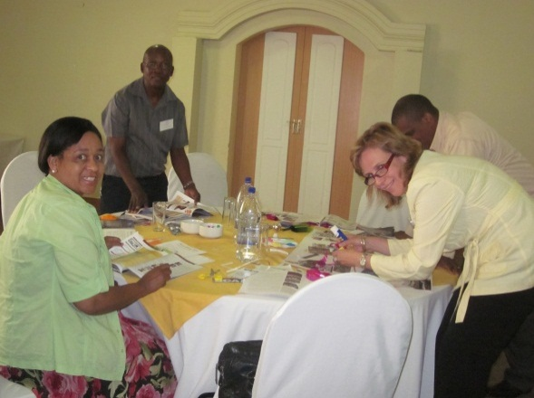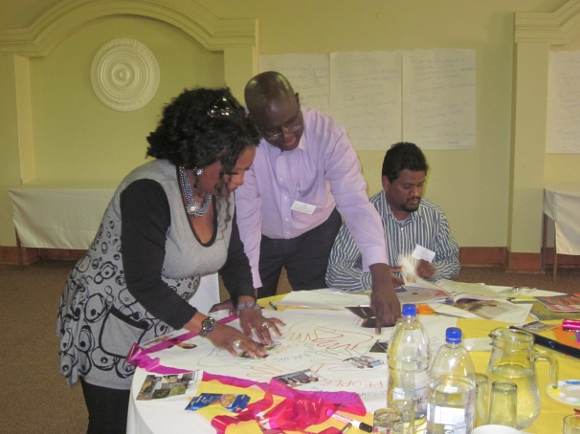
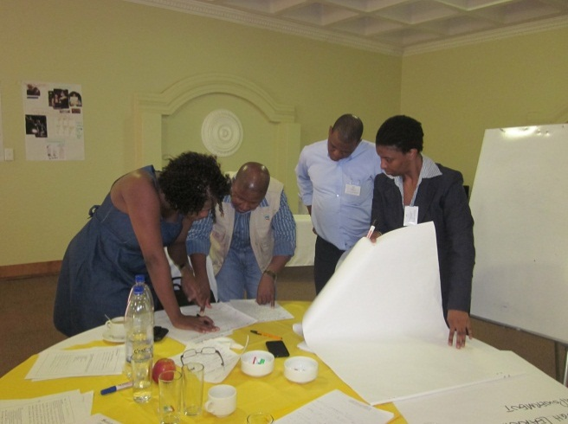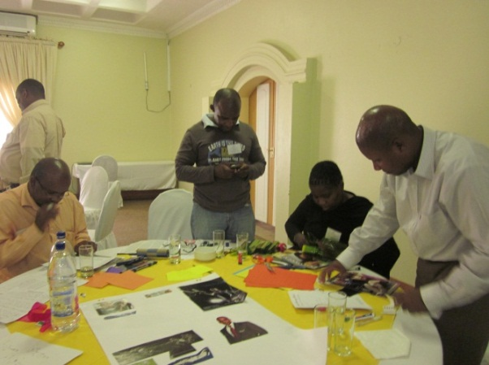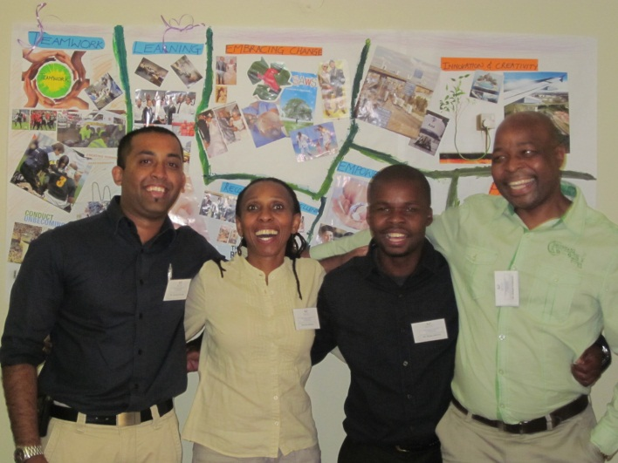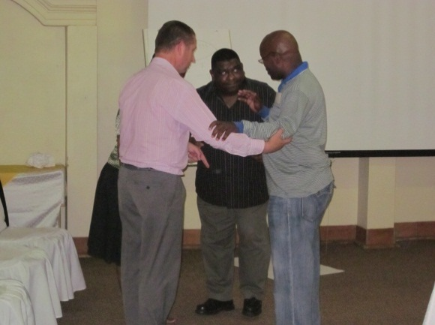
“a too te ta”
(White man dancing)
“a too te ta ta!”
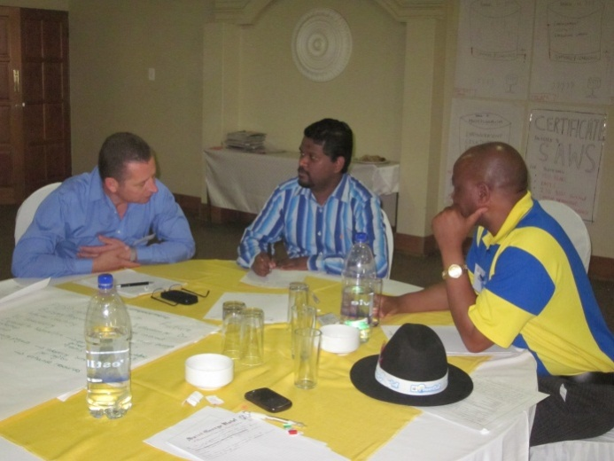

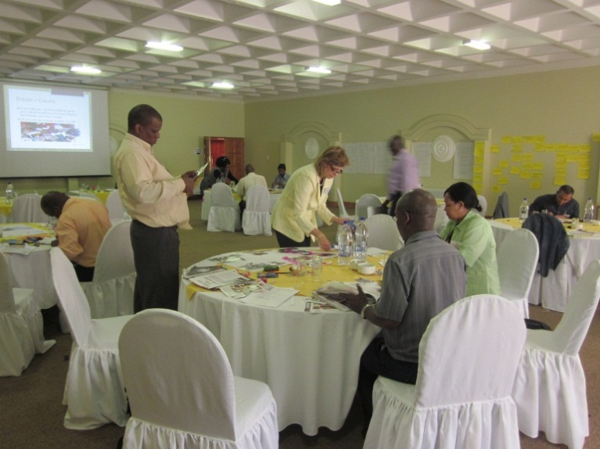

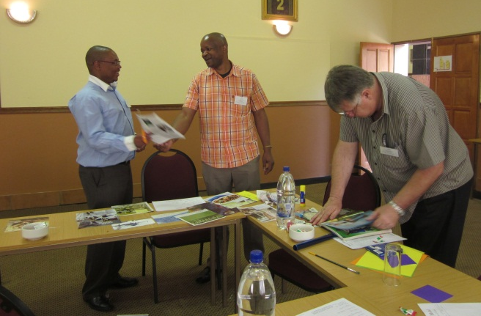

ii ) What did you learn from the inquiry?
My biggest learning was in realising how effective the process is in practice. At first I was apprehensive, but as the process evolved I realised that I did not need to be “in control”. The process takes care of itself, and my role could be one of a true facilitator - ‘to make easy’ - just by opening the process and clearing the way for the participants to make this their own experience. It was not about me – and I liked that. In the Tao of Leadership, by John Heider, chapter 17 describes the leader as midwife: “Remember that you are facilitating another person’s process. It is not your process. Do not intrude. Do not control. Do not force your own needs and insights into the foreground. If you do not trust a person’s process, that person will not trust you. Imagine that you are assisting at someone else’s birth. Facilitate what is happening rather than what you think ought to be happening. When the baby is born, the mother will rightly say “we did it ourselves”. In this AI process in particular, I discovered just how effectively this can work if you introduce the activity, step back, and let it flow, trusting that the individual’s life giving forces will synergise with others, and that the group will identify with each other and find common ground.

iii) What was your "personal best"?
There are a few ‘bests’ for me. Firstly, the story telling part of the process was for me, a wonderful experience. In my work I often use an adapted version of the Johari Window (Luft and Ingham, 1955) model to show people how opening up to each other reduces our hidden and blind spots and reveals our potential. The only way to reduce the hidden and the blind is to reveal more about ourselves to others, and ask for feedback from others. In so doing, the open window opens wider, the blind and hidden are reduced, and potential is revealed. In the sharing of personal stories, and identification of the life-giving forces, that potential is realised (made real).

Known to self
Unknown to self
Known to others
Unknown to others

OPEN
BLIND

HIDDEN

POTENTIAL

In addition to this, I am particularly gripped by the power of empathy – a power that often goes underestimated. Empathy is what gives us the ability to understand the unique experiences of another person, and it is that understanding that heals wounds, establishes interconnectedness, and ignites creativity. The story telling, in my opinion does just that, and I thoroughly enjoyed watching this exhilarating process unfold before me.

Another touching moment for me was at the end of the intervention, when I was thanked by the FD for “the humble manner” in which I had facilitated this process. I felt honoured to work with them, and I enjoyed their process so very much, and I was humbled by the beauty of the experience. I also felt honoured to have been welcomed into their group, as in the beginning they were particularly closed and guarded. I was aware that without the Appreciative Inquiry process, I may not have found it so easy to be as trusted by them as I was in the end.

And lastly, on the first day I had introduced AI and told them an anecdote about how we use AI in my family. Every night, around the dinner table, we ask each other, “What was the best thing that happened to you today”. We have been doing this since my youngest was a toddler and at that time she didn’t understand what we were doing and participated in typical muddled toddler fashion. She is now 5 years old, and of her own volition, she has taken charge of the process, and we all have to answer her question, in her five year old language: “What wath da betht thing dat happened to you today?” On the last day of the summit, a number of participants said they had already introduced the idea in their families and planned to make it their dinner ritual from then on.

- Have you received permission from the "client" or "clients" to tell us their story? In other words, does Company of Experts.net have permission to share this story with others? If not, who would COE.net need to contact to receive permission?
I have received permission for Company of Experts to share this story.

